Discourse #10
Baroque and Neo-Classicism Compare and Contrast

Below is the famous Dutch Baroque painting by Johannes Vermeer The Girl with the Pearl Earring and the Neo-Classical painting by David Napoleon in his study at the Tuileries. Both are portraits painted during two different periods and in different styles. Examine each painting and explain what stylistically would help a viewer differentiate the two paintings by the period in which they were painted. Include in your discussion chiaroscuro, monochromatic, polychromatic color, and hard and soft edges.

,
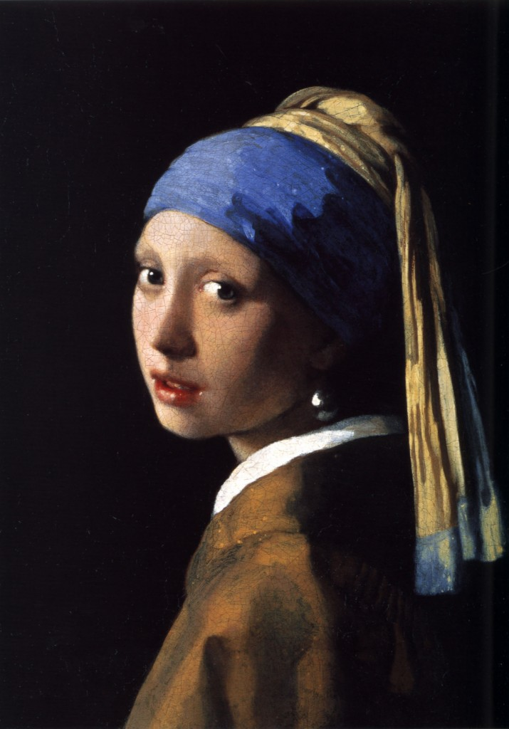
The Girl with the Pearl Earring (1665)

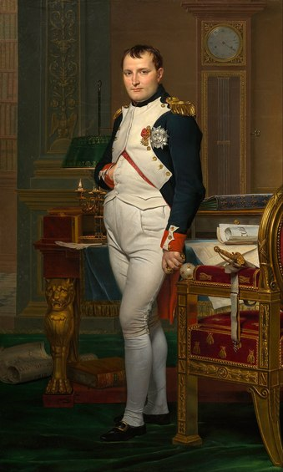
The Emperor Napoleon in his study at the Tuileries (1812)

